**LAB # 01**

**Task 02:**

Draw a flowchart & Write a C++ program to store statement record such as (Name, Age, Grade and CGPA).

**Flowchart:**

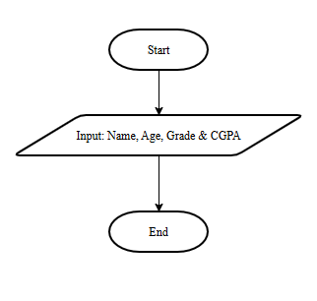

**Code:**

#include<iostream>

#include<string>

using namespace std;

int main(){

    string name;

    int age = 0;

    string grade;

    float cgpa = 0.00;

    cout << "Enter your name: ";

    getline(cin,name);

    cout << "Enter your age: ";

    cin >> age;

    cout << "Enter your grade: ";

    cin.ignore();

    getline(cin,grade);

    cout << "Enter your CGPA: ";

    cin >> cgpa;

}

**Output:**

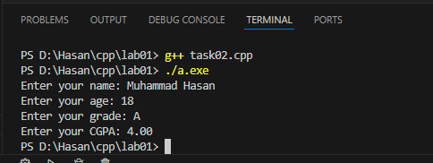

**Task 03:**

Draw a flowchart and Write a C++ program to read student’s three grade, calculate the average of the grade, and then display the average grade.

**Flowchart:**

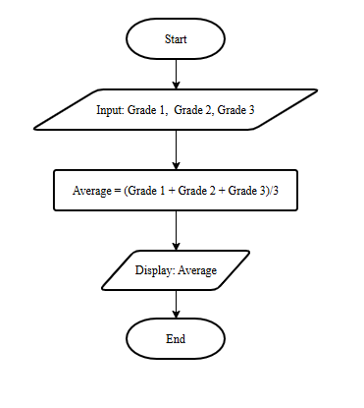

**Code:**

#include<iostream>

using namespace std;

int main(){

    int g1 = 0, g2 = 0, g3 = 0; //g means Grade

    float avg = 0.00;

    cout << "Enter your first grade: ";

    cin >> g1;

    cout << "Enter your second grade: ";

    cin >> g2;

    cout << "Enter your third grade: ";

    cin >> g3;

    avg = (g1+g2+g3)/3.00; // calculating average

    cout << "Your average is: "<<avg;

}

**Output:**

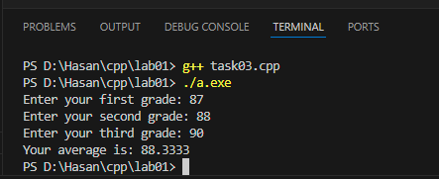

**Task 04:**

Write program & draw a flowchart that reads the height, length, and width of the rectangular box, Calculates and displays the volume.

Note: Volume = lwh.

**Flowchart:**

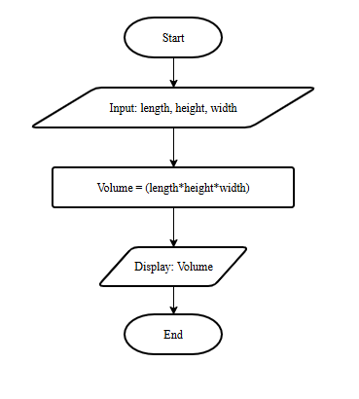

**Code:**

#include<iostream>

using namespace std;

int main(){

    float length = 0.00, height = 0.00, width = 0.00, vol = 0.00;

    cout << "Enter height of rectangular box: ";

    cin >> height;

    cout << "Enter length of rectangular box: ";

    cin >> length;

    cout << "Enter width of rectangular box: ";

    cin >> width;

    vol = height*length*width;

    cout << "The volume of rectangular box is: "<<vol;

}

**Output:**

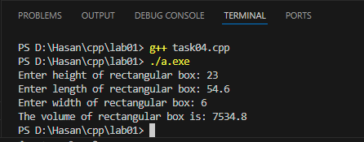

**Task 05:**

Write a program to read the salary of an employee and prints particular designation of the concern person for example Manager Salary = 200k, Supervisor = 150k and Technician = 80k.

**Code:**

#include<iostream>

using namespace std;

int main(){

    int sal = 0;

    cout << "Enter the amount of your salary: ";

    cin >> sal;

    if(sal == 200){

        cout << "Your designation is Manager.";

    }

    else if(sal == 150){

        cout << "Your designation is Supervisor.";

    }

    else if(sal == 80){

        cout << "Your designation is Technician.";

    }

    else{

        cout << "Enter valid amount!";

    }

}

**Output :**

